***Shikha’s Team:***

Members: ***Thejus, Sonal, Vinay, Vishnu, Raju, Sasirekha***

[name of project]:

Test strategy is the document that describes the testing approach of the software product. The test strategy is created to inform project managers, developers, and testers about key issues of the testing process. The test strategy describes how the risks need to be mitigated at the test level, what criteria are needed to apply and the type of testing that needs to be performed. Writing a test strategy is a skill that one develops with experience. The testing strategy needs to be circulated with the whole project team so that the team will be consistent on approach and responsibilities Strategy

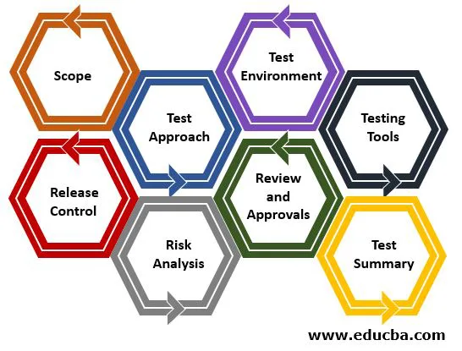

Table of Contents

1. Scope 3

2. Test Approach 4

3. Test Environment 5

4. Testing Tools 6

5. Release Control 7

6. Risk Analysis 8

7. Review and Approvals 9

# Scope

Banca Valla has decided to develop an IDTS.  
Administrators will setup access rights of the application.  
Manager and members will be responsible for testing of this application.  
The timeline given to complete is 3 months but estimates reveals it requires 5 months.  
Customers will review later once all the testing is done.

IN-Scope: Regularly used process comes under this and this need to be tested.

OUT-Scope: Occasionally used process can be merged into this.

# Test approch

# Test Environment

SET UP REQUIRED FOR THE APPLICATION

BROWSERS – IE, MOZILLA FIREFOX, NETSCAPE, EDURA

PROGRAMMING PLATFORM – PROG

DARABASE -DB

SERVER - APPS

# Testing Tools

types of functional and non-functional.

there are number of common software testing tools used by development

teams today

1)test management tools

2)unit testing tools

3) integration testing tools

4 regression testing tools

5)performance testing tools

6) bug tracking tools

7)UI testing tools

there are several testing tools are used like

1) selenium

2) Appium

3) cucumber

4)testing

5)Jira

6) test link

# Release Control

**1.** In the Project The stack holders needs Banca Valla Wants to launch this

system in 3 months.

**2.** Meanwhile the project even though the estimates reveal that it would take 5 months to complete this system with all the identified functionality

# Risk Analysis

* List all risks that you can estimate
* Give a clear plan to mitigate the risks also a contingency plan

# Review and Approvals

When all these activities are defined in the test strategy, A summary of the review changes should be tracked at the beginning of the document along with the approver’s   
name, date and comment.

The following people are required to approve the Test Strategy:  
Test Manager  
The Test Department Manager  
Product Owner  
Development Manager  
Project Manager

One can't change the test strategy once it's been written, and it's been accepted by